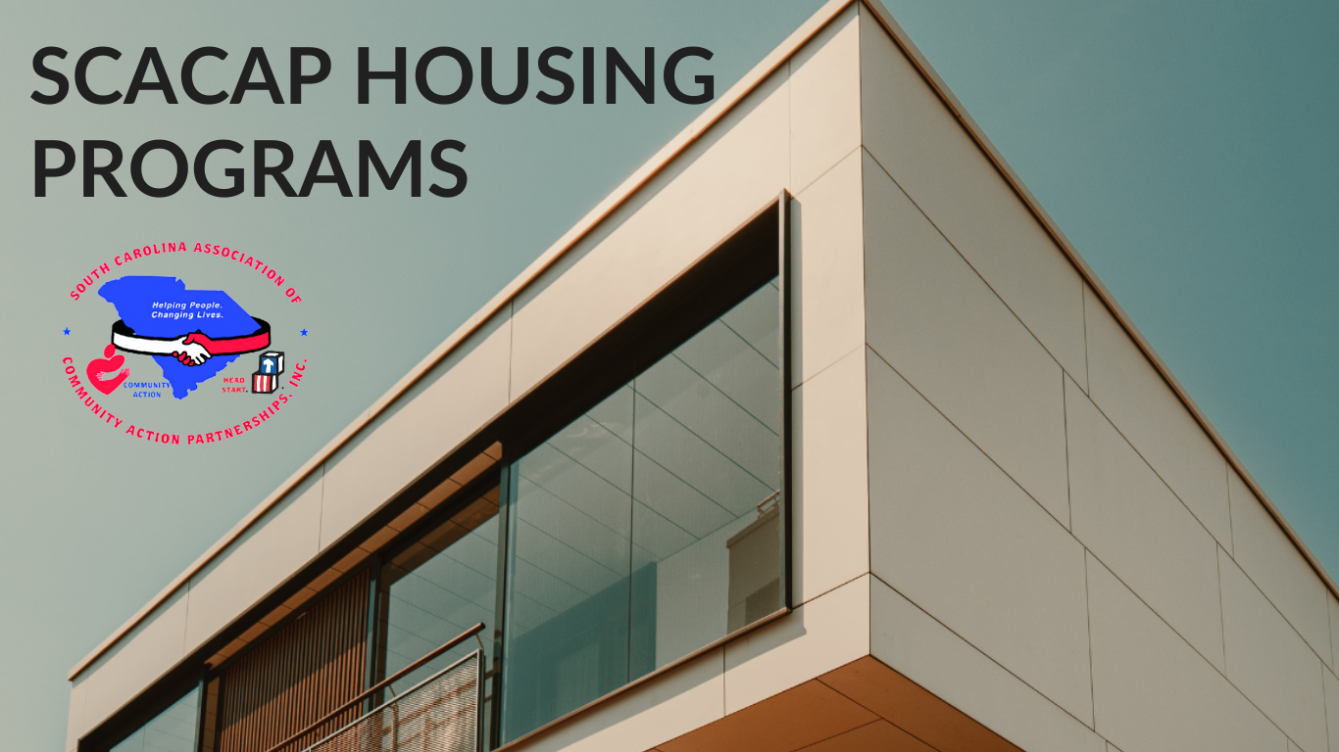

**SCACAP Housing Program Mission**

SCACAP continues to create and coordinate opportunities and options for eligible low-income South Carolina residents. Our overall mission through our housing programs is to improve the quality of "in-home" life for income-eligible individuals and families.



**Services & Strategies**

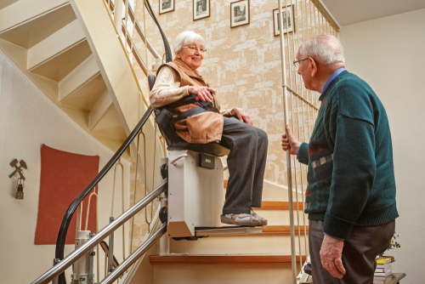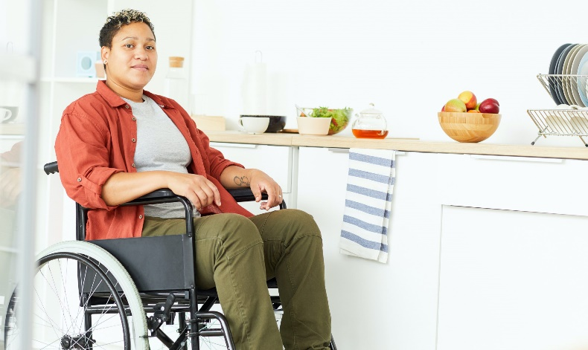****

* A Valid, Government-Issues Photo ID (driver’s license, birth certificate, social security card, etc.)
* A Valid Proof of Government-Issued ID for all residents in the home (driver’s license, birth certificate, social security card, etc.)
* Proof of Home Ownership (copy of deed, property tax bill, etc.)
* For Renters ONLY – Proof of Lease
* Proof of Total Household Income (pay stubs, previous year tax return, W-2, 1099, etc.)

**What do I need to Apply?**

**Learn More**

The Aging In Place Housing Repair Program is related to mitigating the impact of COVID-19 by enabling lowincome elderly Richland County residents to remain in their homes through low-cost/barrier, high-impact home modifications to reduce adults’ risk of falling, improve general safety, increase accessibility, and improve their functional abilities in their homes.

**Aging in Place Housing Repair Program**

**Funded by Richland County**

**Aging In Place Initiative**

**Funded by SC Dept of Social Services**

The Aging in Place Initiative takes the opportunity to provide home stabilization for vulnerable adults, elderly adults, adults with disabilities and adults in need at no cost. Examples of work include repairing holes in roofs and floors, adding handicapped bars, and ramps, and making electrical and plumbing repairs to restore service.

**Learn More**

The Healthy Homes Program addresses the potential for childhood diseases and/or possible injuries that could occur within the home. The program takes a comprehensive approach to these activities by focusing on 29 housing-related hazards in a coordinated fashion rather than one hazard at a time.

**Healthy Homes Program**

**Funded by U.S. Dept of Housing & Urban Development**

 

**Housing Team**

Ka Darius Garrett, *Housing Coordinator*

Charity Smith, *Program Support Technician*

**Mailing Address**

2700 Middleburg Drive, Suite 213

Columbia, SC 29204

**Email Address**

housingdocs@scacap.org

**Phone Number**

(803) 771-9404

**Contact Us**

**Apply Here**

Find out if you or someone you know is eligible to receive free housing modifications.

**Apply Now!!!**