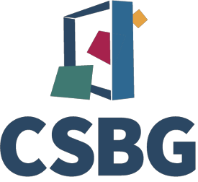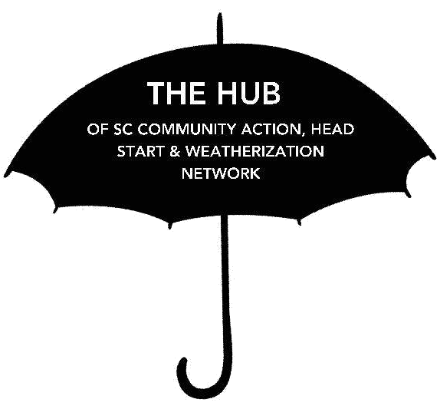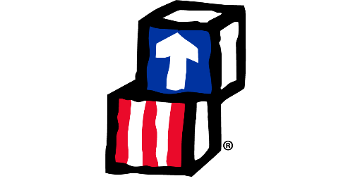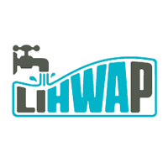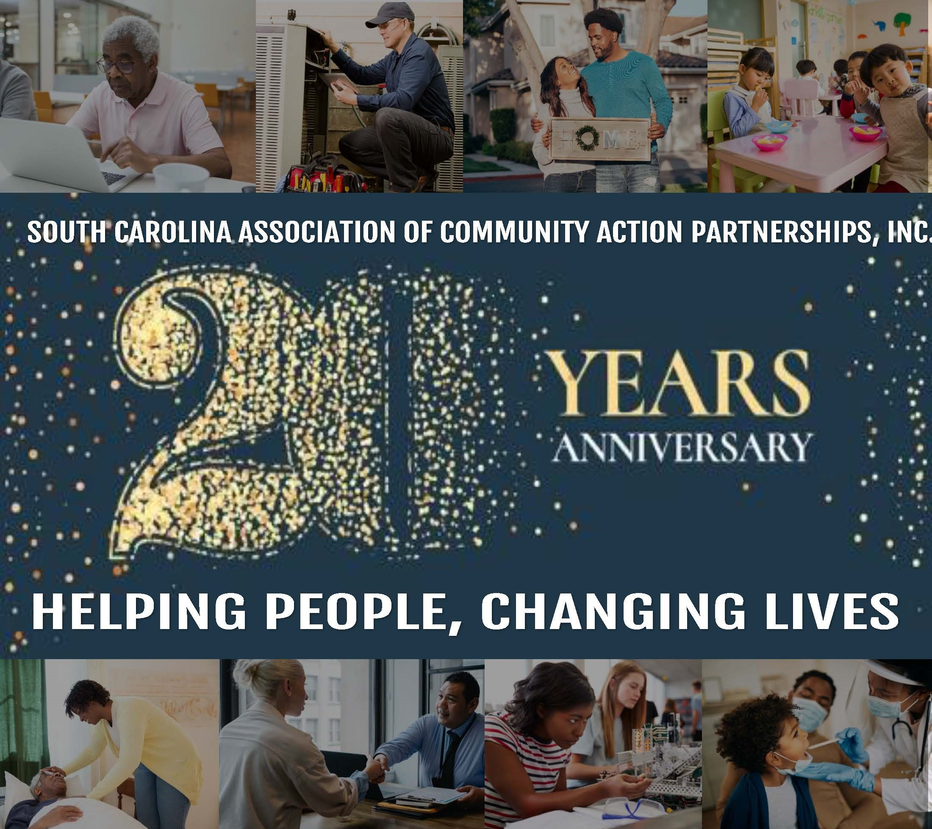

SCACAP serves as a State clearinghouse or Hub for the Community Action, Head Start, and Weatherization Networks that provides various programs and services to meet the needs of our targeted population, such as comprehensive early care, housing, energy assistance and efficiancy programs, crisis and case management, employment, income management, nutrition, youth and senior programs, and a myriad of other programs.

SCACAP PROGRAMS & SERVICES

**DONATE**

SOUTH CAROLINA ASSOCIATION OF COMMUNITY ACTION PARTNERSHIPS, INC.

**HEALTHY HOMES PRODUCTION PROGRAM**

**COVID V.O.I.C.E.S. PROGRAM**

**EARLY HEAD START – CHILD CARE PARTNERSHIP**

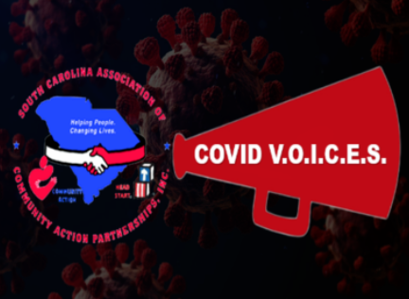

**ORGANIZING FOR OUTREACH**

**AARP READY@50+ DIGITAL SKILLS PROGRAM**

**RURAL HEALTH COVID-19**

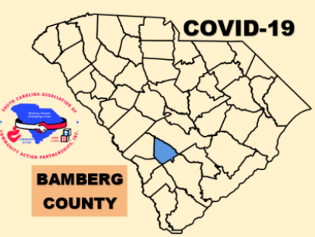

THE COMMUNITY ACTION PROMISE

Community Action changes people’s lives, embodies the spirit of hope, improves communities, and make America a better place to live. We care about the entire community, and we are dedicated to helping people help themselves and each other.

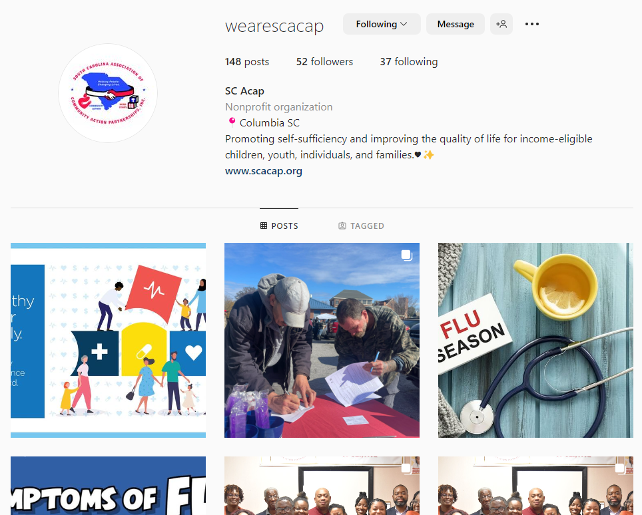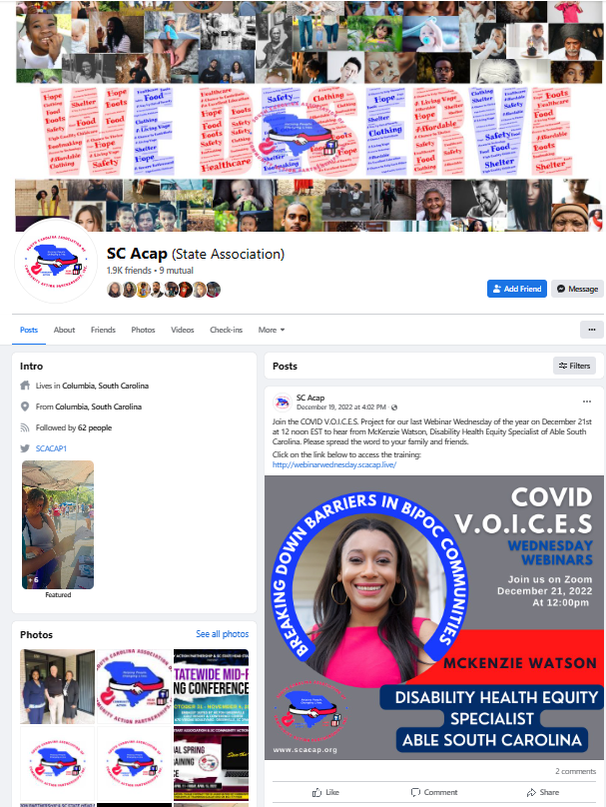

**WHAT IS COMMUNITY ACTION?**

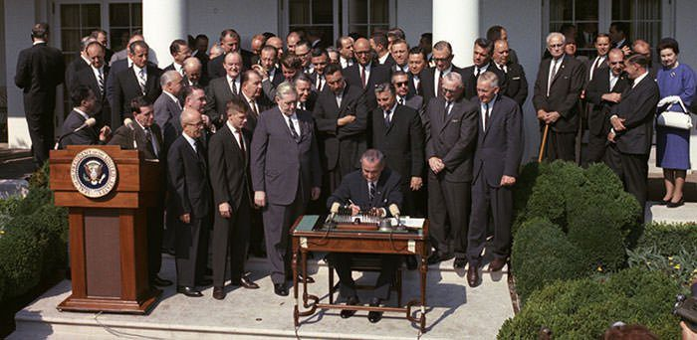

In 1964, The Great Society, as envisioned by President Lyndon Johnson, was a sweeping plan to improve the lives of all Americans, regardless of their circumstances. Inspired by President Kennedy and his New Frontier, Johnson pledged to fulfill his promise of equal opportunity for all by enacting several comprehensive changes within the federal government. In August 1964, the Economic Opportunity Act was signed into law by President Johnson creating the nationwide Community Action Network.

The South Carolina Association of Community Action Partnerships, Inc. (SCACAP) is a statewide non-profit organization that aims to develop and support programs to promote self-sufficiency and improve the quality of lives for income eligible children, youth, individuals, and families served within Community Action and Head Start network in South Carolina.

**SCACAP’s Mission**

**DONATE NOW**

**ABOUT SCACAP**

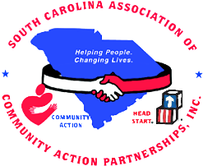SCACAP serves as a State clearinghouse or hub for the Community Action, Head Start, and Weatherization Networks that provides various programs and services to meet the needs of our targeted population, such as comprehensive early care, housing, energy assistance and efficiency programs, crisis and case management, employment, income management Nutrition, youth and senior programs, and a myriad of other programs. SCACAP advocates for policies that strengthen program services, coordinates extensive training, professional development, statewide data compilation and analysis, reporting, communication and marketing, resource and partnership development, research and strategic planning, statewide outreach and education, and a plethora of other services to build the capacity to enrich service delivery. SCACAP also implements statewide community based programming and is currently a grantee of an Early Head Start-Child Care Partnership Program in nine counties throughout the State of SC.

**B O A R D O F D I R E C T O R S**

The South Carolina Association of Community Action Partnerships (SCACAP), Inc. Board of Directors is comprised of eleven members with tripartite representation for each of its Affiliate Associations: South Carolina CAP Directors' Association, South Carolina State Head Start Association, and South Carolina Community Action Partnership.

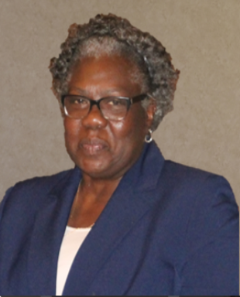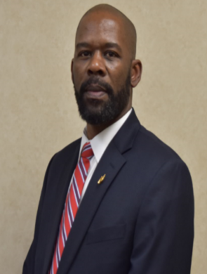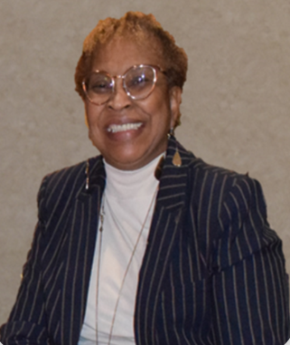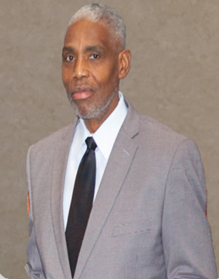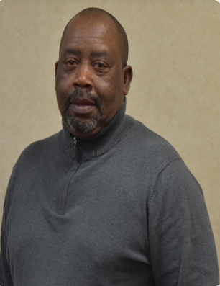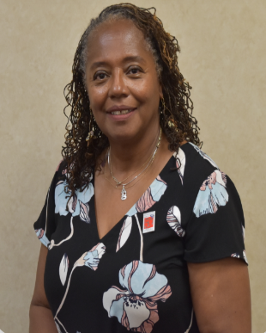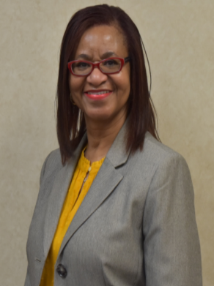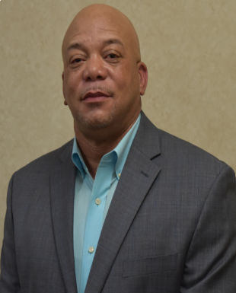

**BOARD EMERITUS**

**Walter Kellogg**

**Leroy H. Gilliard**

**Ross L. Bowens**

**Felecia Davis**

**Loleta Williams**

**SC COMMUNITY ACTION PARTNERSHIP**

**Dr. Arthur Brewton**

**Jerome Thompson**

**Kathyrn Woods**

Vice Chairman

**SC HEAD START ASSOCIATION**

**James G. Willaims**

**George Anderson**

**Calvin Wright**

**Walter Fleming**

Board Chairman

**Pamela Sims**

Board Treasurer

**SCCAP DIRECTORS’ ASSOCIATION**

**MEMBER LOGIN**

**MEET OUR TEAM**

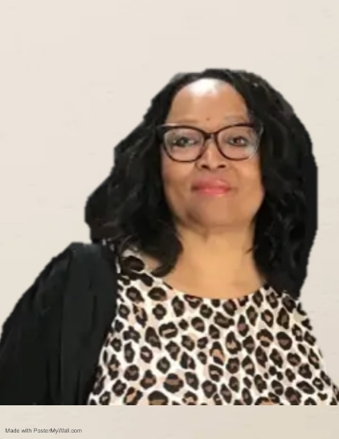

Welcome to the South Carolina Association of Community Action Partnerships, Inc. (SCACAP) website! I would like to take this opportunity to welcome you to our new website. As you scroll through our site, I hope you will get a sense of dedication, commitment, and passion from our staff in delivering high quality services to the low-income individuals, families, and communities in the state of South Carolina.

In my 20+ years of leadership, I have seen firsthand how our society continues to place obstacles and unrealistic challenges that hinder one's process of becoming productive citizens. It is my privilege to work with a dynamic staff and a dedicated board of directors. We are deeply committed to the SCACAP mission, and we work each day with a renewed passion of ***Helping People, Changing Lives.***

We thank you for your interest in SCACAP, and invite you to join us as a collaborative partner in our efforts to make a difference in the lives of those in need in South Carolina. With the utmost respect and cooperation, I remain.

***WORKING TOGETHER, WE CAN MAKE A CHANGE!***

Sincerely,

**Jessica McMoore**

Chief Executive Officer

**Slideshow similar to current page. Remind me to send pictures**

SCACAP IN ACTION

**Sandrea Lawton**

Diaper D.A.S.H. Director

**David Igiozee**

Acting Chief Financial Officer

**Elaina Lamar**

Administrative Coordinator

**Natasha Pauling**

Resource Development/Public Information Officer

**John Johnson**

IT Manager

**Annette Washington**

Human Resources Generalist

**Rebecca Clark**

EHS-CCP Director

**Ka Darius Garrett**

Housing Coordinator

**Fedrick Wilson**

Statewide Outreach Director

**Jessica McMoore**

Chief Executive Officer

**FIND A LOCAL COMMUNITY ACTION AGENCY**

**Insert Map here**

**Remind me to send you each address of the agency. It should send them to their website. (do not put physical location)**

|  |  |  |  |
| --- | --- | --- | --- |
| **Aiken Barnwell Counties Community Action Agency, Inc.**  Aiken  Barnwell  Lexington | **Beaufort Jasper Economic Opportunity Commission, Inc.**  Beaufort  Jasper | **Carolina Community Actions, Inc.**  Chester  Fairfield  Lancaster  Union  York | **Chesterfield Marlboro Economic Opportunity Council, Inc.**  Chesterfield  Marlboro |
| **Darlington County Community Action Agency, Inc.**  Darlington | **GLEAMNS Human Resources Commission, Inc.**  Greenwood  Laurens  Edgefield  Abbeville  McCormick  Newberry  Saluda | **Lowcountry Community Action Agency, Inc.**  Colleton  Hampton | **OCAB Community Action Agency, Inc.**  Orangeburg  Calhoun  Allendale  Bamberg |
| **Palmetto Community Action Partnership, Inc.**  Charleston  Berkeley  Dorchester | **Pee Dee Community Action Partnership, Inc.**  Florence  Marion  Dillon | **Piedmont Community Actions, Inc.**  Cherokee  Spartanburg | **Sunbelt Human Advancement Resources, Inc.**  Greenville  Anderson  Pickens  Oconee |
| **Waccamaw Economic Opportunity Council, Inc.**  Horry  Georgetown  Williamsburg | | **Wateree Community Actions, Inc.**  Richland  Sumter  Kershaw  Lee  Clarendon | |

**CAREERS**

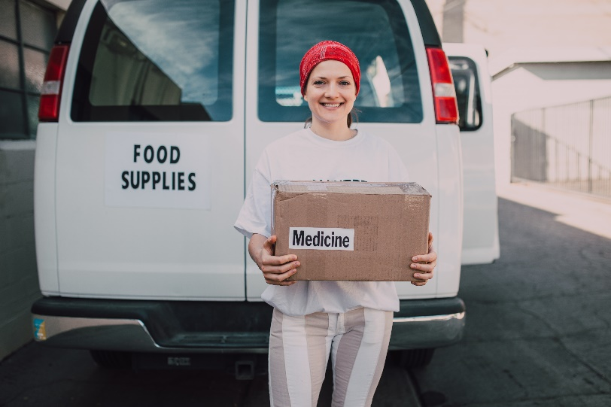

**Mental Health/Disabilities Specialist**

Columbia, South Carolina

SCACAP is seeking highly qualified individual to serve as Mental Health/Disabilities Specialist for its Early Head Start Child Care Partnerships (EHS-CCP) Program. SCACAP provides Early Head Start child care services in nine (9) counties through twelve (12) Child Care Partners across the state of South Carolina.

**Family Advocate**

Georgetown County, South Carolina

The job of Family Advocate is done for the purpose/s of providing quality, comprehensive child/family support services to infant/toddlers and their families; providing support, training, and case management to assist parents in meeting the needs of their children and enhancing parents’ role as the primary influence on their child’s education and development and supporting parents in increasing their economic stability; determining eligibility for program, enrolling families in program, enlisting parental involvement in child educational programs; working with parents in identifying and achieving goals; accessing support services; creating training programs; and facilitating positive parent, school and child relationships.

**If interested in the positions above, please submit your resume and cover/letter to hr@scacap.org.**

*Community Action is more than a job to us. It’s a passion!*